**Apache Portal – Capture Response Time on Chrome**

1. Start Fiddler anywhere and – click capture session
2. On the chrome open Apache JMeter homepage
3. On the Aggregate Duration Tab – Check for the response time
   1. In screenshot below it shows 1362 milliseconds

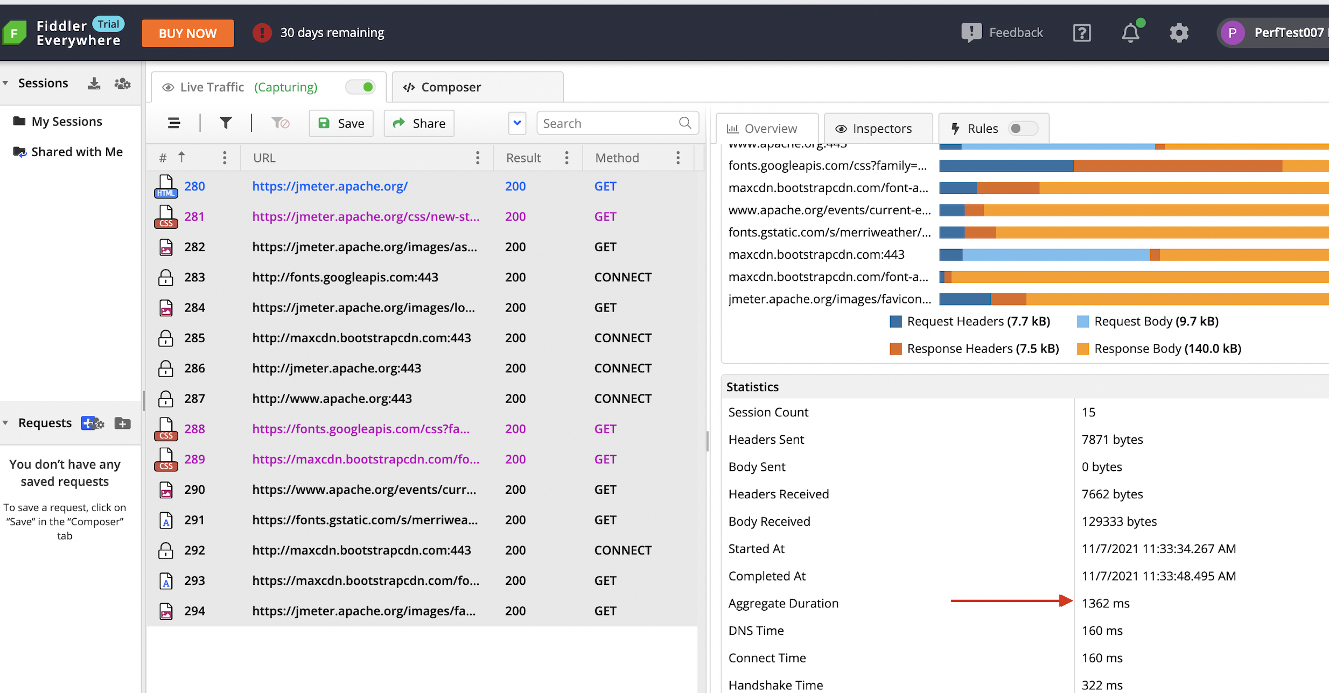

1. The screenshot below shows backend calls triggered and the timings for each of the request is provided in blue

1. Next screenshot is of another transaction on Apache JMeter portal – Distributed Testing
2. Here the page rendering time captured = 1040 milliseconds

